Assessment of Climate Variability and Extreme Weather Events

over Central India

PRIYA NARANG¹, VIKAS MENON² and ARJUN SINGH³
¹Scientist-C, Regional Meteorological Centre, Bhopal-462001
²Assistant Professor, Department of Atmospheric Sciences, XYZ University, New Delhi-110067
³Research Fellow, National Climate Research Institute, Pune-411008
(Received 15 December 2025, Accepted 20 March 2026)
Corresponding author’s email: priyanarang@imd.gov.in

सार— वर्षा प्रवृत्ति विश्लेषण का अध्ययन जलवायु परिवर्तन को समझने के लिए अत्यंत महत्वपूर्ण है|

ABSTRACT: This study investigates long-term climate variability and extreme weather events over Central India using 25 years (2000–2024) of meteorological observations. Trend analysis was performed using linear regression and Mann–Kendall test. Results indicate increasing rainfall variability and a rise in extreme rainfall events. The study highlights implications for disaster risk reduction and climate-resilient planning.

Key words: Climate variability, Extreme rainfall, Mann–Kendall test, Trend analysis, Central India.

1. Introduction

Climate variability has significant impacts on water resources, agriculture, and disaster management. Recent decades have shown increasing frequency of extreme weather events across India.

2. Data and methodology
Daily rainfall and temperature data from 2000 to 2024 were analyzed. Statistical methods such as linear regression, coefficient of variation, and Mann–Kendall test were applied.

2.1. Study area

The Jambhira basin is a small river basin on the north coast of Odisha, located between latitudes 21⁰ 30ʹ N to 22⁰ 7ʹ 48ʹʹ N and longitudes between 86⁰ 45ʹ E to 87⁰ 8ʹ 24ʹʹ E.

Table 1. Summary of Annual Rainfall Statistics
Year | Annual Rainfall (mm) | Extreme Events
2001 | 1096 | 11
2002 | 1066 | 18
2003 | 1015 | 8
2004 | 1269 | 18
2005 | 1371 | 15

2.2. Data
2.3 Methodology

3. Results and Discussion

Figure 1 shows the annual rainfall trend over the study period.
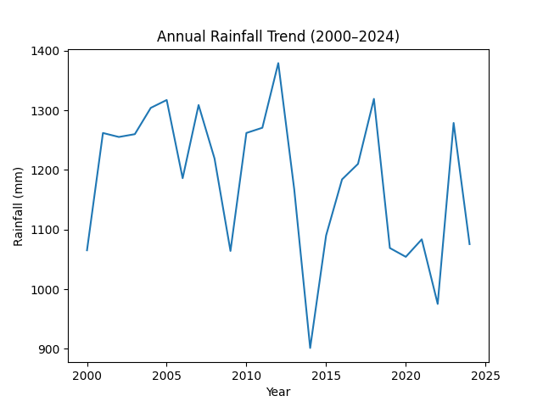
Fig. 1. Illustrates the increasing trend of extreme rainfall events.
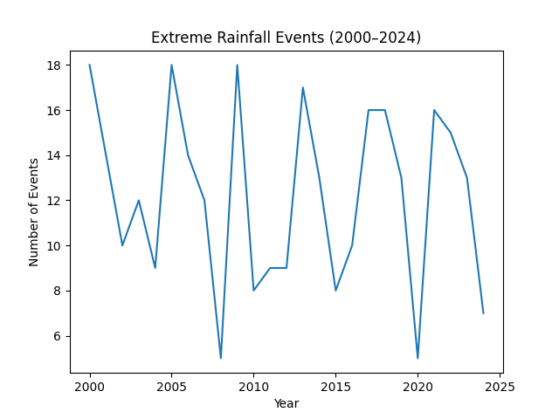

4. Conclusions
The study indicates increasing variability and extreme rainfall events over Central India. Improved forecasting systems and adaptive infrastructure planning are recommended.

Data availability

Daily rainfall data is available online from the Special Relief Commissioner, Odisha. (www.srcodisha.nic.in)

Funding

No fund provided for the preparation of the research paper.

Acknowledgement

Authors are appreciative to Special Relief commissioner (SRC) for contributing daily rainfall data of the research area for rainfall and climate change analysis. The view expresses are of the authors without any conflict of interest.

Authors’ contributions

Priya Narang: The conception and design of the study and drafting the article.
Vikas Menon: Analysis and interpretation of data. (email-rashmi.rani@sbs.du.ac.in).
Arjun Singh: Acquisition of data and revising it critically. (email-mdevifpy@kiit.ac.in).

Disclaimer: The contents and views presented in this research article/paper are the views of the authors and do not necessarily reflect the views of the organizations they belong to.

References

Alexander, V. L., 2016, “Global observed long-term changes in temperature and precipitation extremes: A review of progress and limitations in IPCC assessments and beyond, Weather and climate extrenes, 11, 4-16.
Buytaert, W., Celleri, R., Willems, P., Bievre, B.D. and Wyseure, Guido., 2006, “Spatial and temporal rainfall variability in mountainous areas”, A case study from the South Ecuadorian Andes. Hydrology Journal, 414, 01-09.
Chaudhary, Dhanya, C. T. and Vinnarasi. R., 2017, “Dry and based gridded daily precipitation datasets over India”, Journal of Hydrology” 546, 204–218.
Chhibber, A and Lajaaj, R., 2008, “Disaster, Climate change and economic development in Sub-Saharan Africa: Lesson and Directions”, Journal of African Environment, 17, ii7-ii49.

